LAB 2 WEB ENGINEERING

MUJTABA SHAHID FAIZI

BSCS-5A

131818

**CODE:-**

<!DOCTYPE html PUBLIC "-//W3C//DTD XHTML 1.0 Transitional//EN" "http://www.w3.org/TR/xhtml1/DTD/xhtml1-transitional.dtd">

<html xmlns="http://www.w3.org/1999/xhtml">

<head>

<title> Mujtaba Shahid Faizi </title>

<meta http-equiv="Content-Type" content="text/html; charset=utf-8" />

<title>Untitled Document</title>

</head>

<body>

<DIV ID="title"

style="background-color:yellow">

<blockquote>

<p align="center"> Personal Info:

</p>

</blockquote>

</DIV>

<DIV ID="form" style="background:#CFC">

<form>

<p align="center">

<p>

<label for="firstname">first name: </label>

<input required type="text" id="firstname">

<p><br />

<label for="lastname">last name: </label>

<input required type="text" id="lastname">

<p><br />

gender:

<p>

<input type="radio" name="gender" value="male">

male

<br>

<input type="radio" name="gender" value="female" checked>

female<br/><br/>

<label for="text">Email: </label>

<input required type="text" id="email" /><br/><br/>

<label for="password">Password:</label>

<input type="password" name="password" /><br/>

<p>Semester:<br/>

<select name="select">

<option value="1">1</option>

<option value="2">2</option>

<option value="3">3</option>

<option value="4">4</option>

<option value="5">5</option>

<option value="6">6</option>

<option value="7">7</option>

<option value="8">8</option>

</select>

<br/>

<p>Favourite Color:<br/>

<select name="select">

<option value="1">red</option>

<option value="2">blue</option>

<option value="3">green</option>

<option value="4">white</option>

<option value="5">black</option>

<option value="6">orange</option>

<option value="7">purple</option>

<option value="8">yellow</option>

</select>

<BR/>

<br/>

<label for "DOB">Date of Birth:</label>

<input type="date" id="DOB" /><BR/><BR/>

<label for "CNIC">CNIC:</label>

<input type="text" id="DOB" pattern="[0-9]{5}[-][0-9]{7}[-][0-9]{1}" /><BR/><BR/>

<label for "PHONE">phone number:</label>

<input type="tel" id="PHONE" pattern="[0-9]{4}[-][0-9]{7}" placeholder="XXX-XXXXXXX" maxlength="11"/><br/><br/>

<p>Month of Joining:<br/>

<select name="select">

<option value="1">Jan</option>

<option value="2">Feb</option>

<option value="3">March</option>

<option value="4">April</option>

<option value="5">May</option>

<option value="6">June</option>

<option value="7">July</option>

<option value="8">Aug</option>

<option value="5">Sept</option>

<option value="6">Oct</option>

<option value="7">Nov</option>

<option value="8">Dec</option>

</select> <br/><br/>

<label for="city">City:</label>

<input list="city" />

<datalist id="city">

<option value="Rwp"></option>

<option value="Isb"></option>

<option value="Lhr"></option>

<option value="Karachi"></option>

<option value="Quetta"></option>

<option value="Peshawar"></option>

</datalist>

<BR/>

<br/>

<label for="EXPERIENCE">experience:</label>

<input type="range" name="EXPERIENCE" min="0" max="20" />

<br/>

<br/>

<input type="submit" name="submit" value="Submit">

<input type="reset" name="reset" value="Reset">

</form>

</DIV>

<BR/>

<DIV ID="form" style="background:#9C6">

<video width="320" height="240" AUTOPLAY>

<source src="videoplayback.mp4" type="video/MP4">

</video>

<audio controls>

<source src="Breaking Benjamin - Had Enough LYRICS.mp3" type="audio/mpeg">

</audio>

<embed src="car.swf">

</DIV>

</body>

</html>

**Output:**

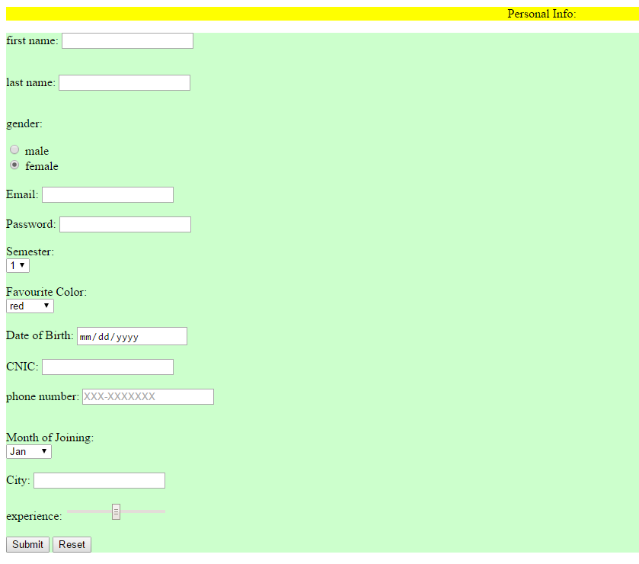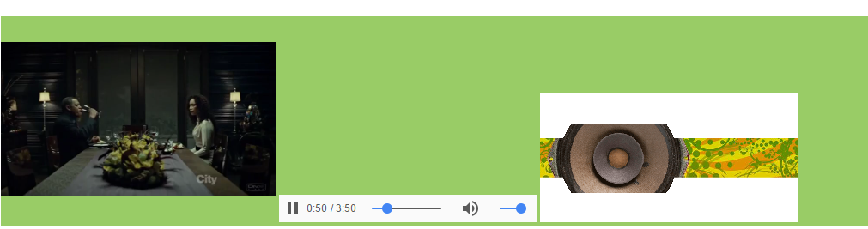

**Description:** by the <**div**> tag, I have defined 3 sections in an HTML document, each with a different color. By using form tag, I have defined various input types like date, text, radio, lists, etc to get inputs from the user. By using video and audio tags, I have uploaded a mp4 and an mp3. Finally, I have uploaded a flash file.